**Lab 3 - Begisbayev Diar SE-2118**

Task 1: Max volume on interval between 3rd and 4th peaks - ~221 cubes

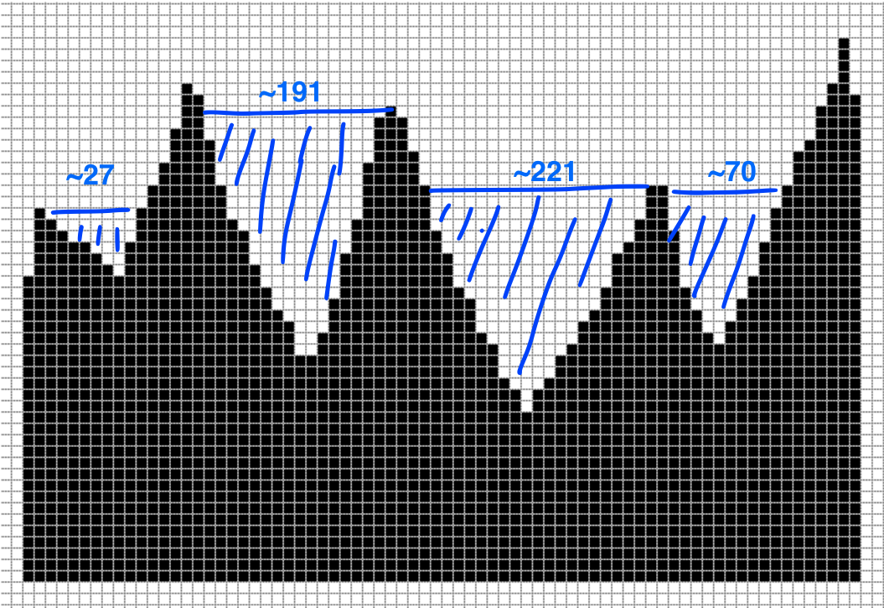

arrOfNumbers = []

indexOfPeaks = []

maxVolume = 0

for i in range(indexOfPeaks.size()):

volume = 0

for k in range(arrOfNumbers.size()):

height = min(indexOfPeaks[i], indexOfPeaks(i+1))

columnVolume = arrOfNumbers – height

volume += columnVolume

if(volume > maxVolume):

maxVolume = volume

Task 3: The longest icicle that fits condition that length must be greater than width is icicle between 2nd and 3rd peaks with length 22

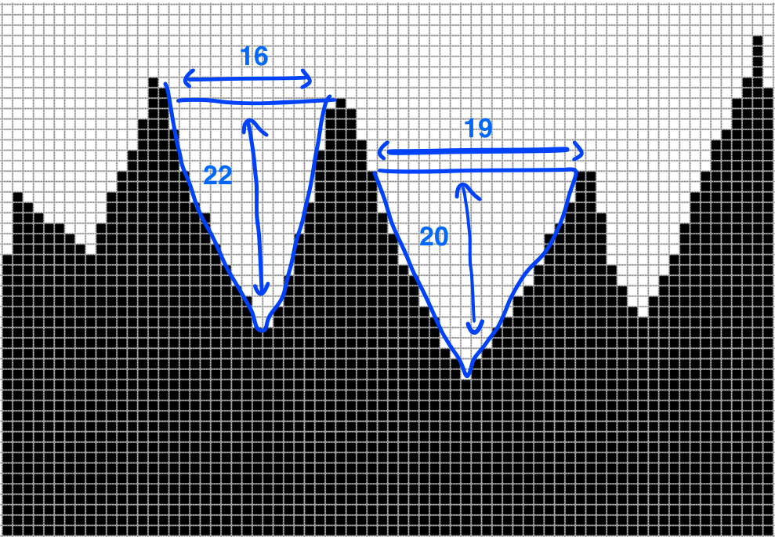

arrOfNumbers = []

indexOfPeaks = []

maxHeight = 0

for i in range(indexOfPeaks.size()):

length = indexOfPeaks[i] – indexOfPeaks[i+1]

height = min(indexOfPeaks[i], indexOfPeaks(i+1))

if(length > height and maxHeight < height):

maxHeight = height

Task 6: The longest ropeway on this profile with a length of 58 cubes stretches between the 2nd and 5th peaks of the mountains

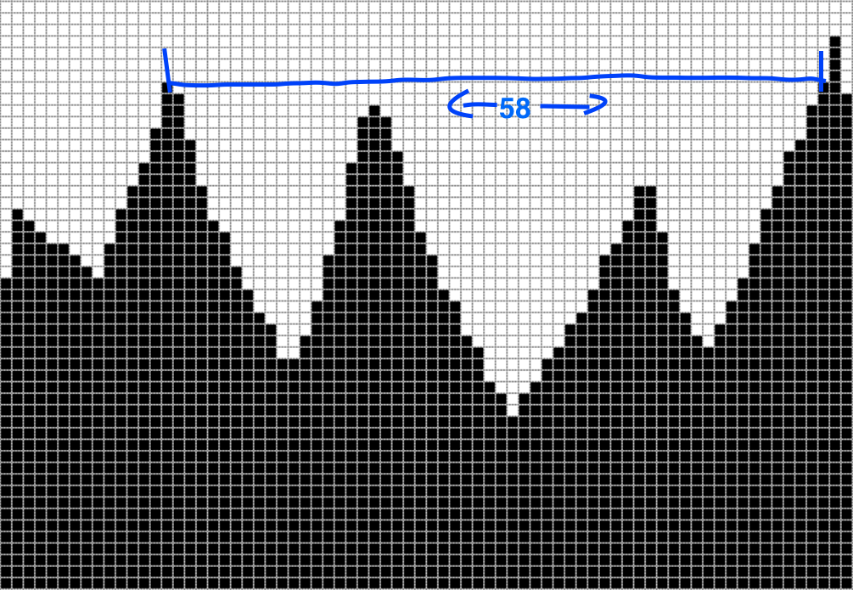

arrOfNumbers = []

indexOfPeaks = []

maxLength = 0

for i in range(indexOfPeaks.size()):

while(indexOfPeaks[i+1] < indexOfPeaks[i]):

length = indexOfPeaks[i+1] - indexOfPeaks[i]

maxLength += length